Bahria University,

Karachi Campus

COURSE: CEN-409 ARTIFICIAL INTELLIGENCE

AND MACHINE LEARNING

TERM: FALL 2023, CLASS: BCE- 7A

Submitted By:

**DANIA SAMI**  **02-132202-025**

(Name) (Reg. No.)

Submitted To: **Engr. Qasim Hassan**

Signed Remarks: Score:

Bahria University,

Karachi Campus

LAB ASSIGMENT: 03

LIST OF TASKS

|  |  |
| --- | --- |
| TASK NO | OBJECTIVE |
| 1 | Write a Python program to construct the following pattern, using a nested for loop. |
| 2 | Write a Python program that accepts a sequence of comma separated 4 digit binary numbers as its input. The program will print the numbers that are divisible by 5 in a comma separated sequence. |
| 3 | Write a Python program to convert a month name to a number of days. Expected Output: |
| 4 | Write a Python program to convert a month name to a number of days. Expected Output: |
| 5 | Write a Python program to convert a month name to a number of days. |

Submitted On:

09 /10/2023

(Date: DD/MM/YY)

**TASK NO 01:**

**RETORT:**

**TASK NO 02:**

**RETORT:**

**TASK NO 03:**

**RETORT:**

**TASK NO 04:**

**RETORT:**

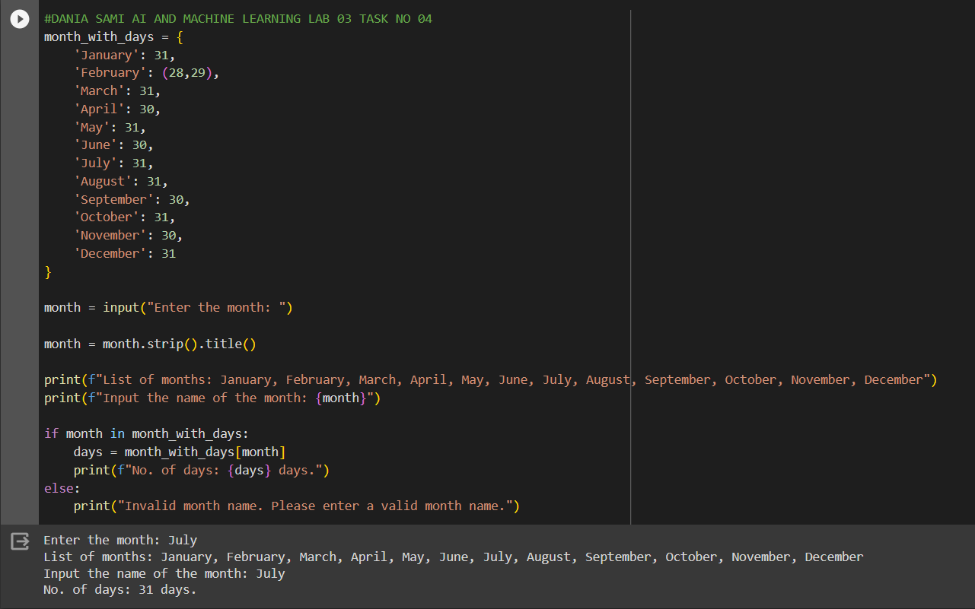

**TASK NO 05:**

**RETORT:**

